SMS[Short Message Service] SPAM DETECTOR
SMS spam detection is an important task where spam SMS messages are identified and filtered. As more significant numbers of SMS messages are communicated every day, it is challenging for a user to remember and correlate the newer SMS messages received in context to previously received SMS. Thus, using the knowledge of Java Script. we develop web-based SMS text spam or ham detector. Short Message Services (SMS) is far more than just a technology for a chat. SMS technology evolved out of the global system for mobile communications standard, an internationally accepted. SMS Spam in the context is very similar to email spam’s, typically, unsolicited bulk messaging with some business interest. SMS spam is used for commercial advertising and spreading phishing links. Commercial spammers use malware to send SMS spam because sending SMS spam is illegal in most countries. Sending spam from a compromised machine reduces the risk to the spammer because it obscures the provenance of the spam. SMS can have a limited number of characters, which includes alphabets, numbers, and a few symbols. A look through the messages shows a clear pattern. Almost all of the spam messages ask the users to call a number, reply by SMS, or visit some URL.

Sample : 1
Paste your Text Message for Checking Spam SMS
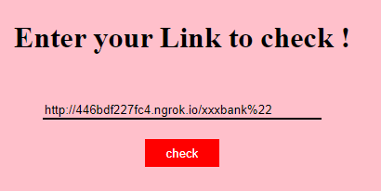

After Analysis It will Promote the Result .

Sample Result “SMS SPAM DETECTOR”

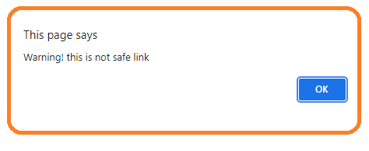

Sample : 2

Paste your Text Message for Checking Spam SMS


Sample Result “SMS SPAM DETECTOR”
